YUVAK & COMPANY
CHARTERED ACCOUNTANTS
406, Siddheya Apartments, Nathalal Parekh Road, Wadala (W), Mumbai – 400031.
Contact No.: 9820321864 / 022-24151504 E-mail ID: yuvakco@hotmail.com

To,
The Hon. Chairman
Mumbai Bank Sevak Sahakari Patsastha Ltd., Mumbai

Date – 7 January 2017

Sub: Proposal for conducting the Tax Audit of the Employee Soceity for FY 2016-17 (AY 2017-18) as per the requirement of the Income tax Act, 1961.

Respected Sir,

With reference to the captioned subject, we had conducted the Tax Audit and ITR filing for your Employee Society for FY 2015-16.

We now offer our proposal for being appointed as the Tax Auditor of your Employee Society for Financial Year 2016-17 (AY 2017-18) and also assist the Society with its filing of the Income tax Return (ITR) for the said FY.

Our Fees for above mentioned work would be Rs 22,000/- (Rupees Twenty Two Thousand) plus applicable Government Taxes.

Assuring you the best of the cooperation during the conduct of our audit.

Thanking you,

For Yuvak & Company
Chartered Accountants
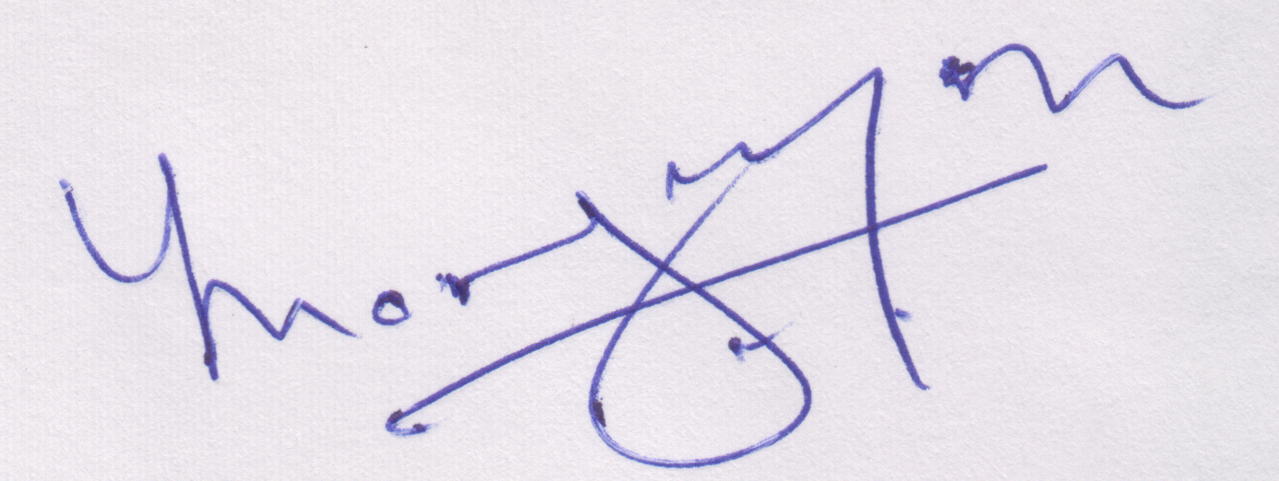
(CA Yuvak Mangaonkar)
Partner
M. No. 105886
Audit Panel No. 1011007

